Upton Junior School

BROADSTAIRS



SCHOOL HANDBOOK
2013-2014
Information for Families

‘One Childhood, One Chance’

Kent County Council
Upton Junior School
Edge End Road
Broadstairs, Kent, CT10 2AH
Telephone: (01843) 861393
Fax: (01843) 608498
Absence Line: (01843) 608499 24 hour answerphone to be used for reporting all absences.
E-mail: office@upton.kent.sch.uk

Headteacher: Mrs M lewis (01843) 861393
Email: headteacher@upton.kent.sch.uk

Twitter: @uptonjuniors
Facebook: Upton Junior School, Broadstairs – Official

Chairman of Governors: Mr M Webb (01843) 861393

Contents Page

Welcome 3
Our School 4
Vision & Values 5
Core Values 5
Parents are important too 7

Section 1 9
General Information

Section 2 18
Curriculum

Section 3 22
Special & Additional Needs

Section 4 24
Pupil Safeguarding

Section 5 28
General Information

WELCOME
‘One Childhood, One Chance’

Dear Parents

I welcome you and your child to Upton Junior School. I hope that it is the beginning of a long and happy association with our school. Our aim is, at all times, to ensure that every child makes the most of his or her abilities. Success is a great motivator and all children have the right to enjoy success.
Our 'vision' is to provide a high-quality, rounded and creative education, through which every child can know the joy of learning, and be supported to reach his or her potential. All children have strengths. These can readily be seen in academic achievement or in artistic, musical, dramatic and sporting success. Equal to these are the abilities which help us to excel as people. We aim to create a calm yet highly stimulating environment, within which every child can feel secure and grow in self-confidence, gaining the necessary personal, social and academic life-skills to succeed in a rapidly changing world - whilst never forgetting the vital importance of such "traditional values" as courtesy and thought for others.
We hope that Upton Junior School stands at the centre of the community. The school is well-known in the area for its heated indoor swimming pool, which is used by many other local schools and organisations. The school playing fields are used by our children, and many sports groups. The partnership between home, school and the wider community is integral to the success of Upton and we wholeheartedly believe in working together for the benefit of our children.
I look forward to getting to know you and your child during the time we will share together at Upton Junior School.

Mrs Michaela Lewis
Headteacher

OUR SCHOOL
‘One Childhood, One Chance’

Upton Junior School was opened in 1971. Our pupils mainly come from the seaside town of Broadstairs, Kent.
We currently have 16 classes in 4 year groups. We have a dedicated, experienced staff that share the vision and values of our Headteacher. Our staff are united in upholding our ‘Core Values’ and ensuring Upton Junior School continues to provide an outstanding education to all of our pupils.
Our extensive grounds host many and varied activities, including sports tournaments, Folk Week campers and fairs. We have an environmental area, with pond and also a 25 metre swimming pool.
We hold the Investors in People award, the Football Association Charter Mark, Quality in Study Support mark and Healthy School Status. As a healthy school we have ‘Caterlink’ provide catering facilities and staff. Our meals are excellent! We actively encourage our pupils to choose a healthy life style and have cycle facilities to support pupils that ride (or scooter!) to school.
We are especially proud of our sporting and music traditions. Our teams are very successful in local tournaments and often at county and national level. We were recently awarded ‘the Aviva / Telegraph ‘PRIMARY SCHOOL of the YEAR’ award at the School Sports Matters Awards and our ‘Boys Swimming Team’ recently won Gold at the National Primary School Swimming Competition.
Our designated music coordinator runs many music groups in the school; we have a choir, Rock Band, String & Brass Group. We perform at various local events for example; ‘The Bandstand’, Broadstairs during Dickens Festival and the Winter Gardens for the Schools Prom. We perform a fabulous production every year at a local theatre with the Year 6 pupils. Extra music tuition can also be provided from the Kent Music School tutors.
As an extended school we are open from 7:50am for Breakfast Club until 6:15pm with our After School Club. We have a wide variety of clubs for pupils to participate in; held during the school day as well as after school. We are confident that we provide exciting educational experiences for all our children to enjoy! The UPTFA support our school with fundraising events. These are popular and well attended.
VISION & VALUES

‘One Childhood, One Chance’

We aim to provide a safe, secure and caring environment in which every child is
able to learn confidently and happily in order to fulfil their potential. We
recognise that children learn best in a calm, orderly atmosphere.

The foundation of our school is based on mutual respect, we will deal with each other in the way that we would like to be treated ourselves.

At Upton Junior School we believe that:

- All individuals will show care and respect for each other:
  - Adult/child
  - Adult/adult
  - Child/adult
  - Child/child

- All individuals have the right to be listened to and heard.

- All individuals will have a clear understanding of the shared expectations of their own and others’ behaviour.

- All individuals will take responsibility for positively encouraging each other to behave in a way that fits the caring ethos of the school.

- All individuals will try to emphasise the positive and seek positive solutions to problems.

- All individuals to be consistent in supporting this ethos.

- We believe that this will apply to ALL individuals who are involved in the life of the school, i.e. pupils, parents/carers, teachers, teaching assistants, learning mentors, mid-day meal supervisors, office staff, caretaking & cleaning staff, kitchen staff, governors and all visitors to the school.

CORE VALUES
‘One Childhood, One Chance’
Our ‘core values’ are those things which we see as being at the heart of our school. We have four years with your child; four years to ensure that they achieve the very best that they can academically, but also, four years in which we play a huge part in shaping the person within.

Some things remain timeless and priceless. What mattered then, matters now: respect; perseverance, tenacity, endurance, commitment, kindness, civility, academic rigour, culture, a sense of time and place, a willingness to embrace responsibility and forgiveness. All seem enduringly relevant.

Our children are growing up in a changing and competitive world; at this moment in time, a world in recession, where examination results and qualifications are ever more significant. It is also a future in which interpersonal skills and electronic technology are vital. Our task is to assist children come to terms with the demands that adulthood imposes.

We feel it is fundamental to all we stand for that such an importance is given to developing our core values with our pupils. Ultimately, we are helping to shape responsible citizens with personal goals and aspirations for the future.

Our Core Values…
Respect
Value yourself and others

Excellence
Strive to always do your best

Community
Take part and do your share

Resilience
Never give up, even when it’s hard

Enjoyment
Make it fun

Compassion
Kindness & friendship

Parents are important too!

At Upton Junior School, we believe that if parents are involved in their child's learning, and are enthusiastic about education, then the child has a better chance to succeed. We welcome parents’ involvement in all aspects of school life.
We involve parents in our school life in the following ways:
- Parent governors
- Friends of Upton Parent Teacher Association (UPTFA)
- Parent workshops (eg Maths, Read, Write Inc, Reading)
- Open classroom sessions
- Class assemblies
- Christmas performances
- End of year show
- Helping with school trips and in-school activities (eg Year 3 Sandwich making day)
Learning Mentors
We have two Learning Mentors that work with parents and children; Ms Danson and Mrs Turner. The ladies can be a first point of contact for parents, somebody who can liaise between home and school. Our Learning Mentors role is to ensure every child’s well being is high and they are emotionally ready and able to learn.
How you can help your child progress at school…
1. Be interested. Make sure your child knows you are interested in what they have done at school and what they are learning. Don't be afraid of asking your child's teachers for information.
2. Read. Please read with your child for ten minutes or more each day. You could read to them or listen to them read to you. It doesn't always have to be a school book either - home books, newspapers, the internet, leaflets and even comics can all count. Try to keep it fun and interesting for you both.
3. Maths Basic Skills. Practise number bonds, basic adding and subtracting, times tables and quick answers to maths questions as often as you can. Practising these skills is easy but it keeps minds sharp and really helps children to reach the top in maths at school. My Maths programme is great for supporting home learning!
4. Home Learning. Please check your child's bookbag every day and help them with any homework given.
Communication: Our newsletter goes home to parents once a fortnight (always on a Wednesday) Our newsletters celebrate pupil achievement as well as informing parents of forthcoming events. It also allows us as a school to share our values and expectations. The newsletter is also on our school website www.upton.kent.sch.uk along with key information for parents.
We also have our FaceBook and Twitter accounts to share information and celebrate the children’s achievements.
Year Leaders send home a Year Group Newsletter at the start of Terms 1, 3 & 5. Email addresses for teachers are listed here for parents to use as a means of communication if they wish. Termly topics and ‘special events’ are also shared as part of the Year Group Newsletter.
Being an ‘Eco School’ we look for ways to minimise sending home letters. We encourage parents to keep us informed of mobile numbers and email addresses as we try to communicate electronically as often as possible!

Section 1
General Information
Page
- Staffing list 10
- Staff email 11
- Map of the school 12
- Organisation 13
- Teaching & learning 13
- Parental Input 13
- Use of premises 13
- Parking 13
- Lost Property 13
- Jewellery, valuables, money 14
- School meals 14
- Charging policy 14
- School Voluntary Fund 14
- Accidents & emergencies 15
- First aid procedures 15
- Administering medicines in school 15
- Pupil absence 15
- Home school agreement 15
- Homework 15
- Pupil voice 15
- School travel plan 15
- Uniform 16
- Swimming 16
- Protective clothing 16
- Assessment & reporting to parents 17

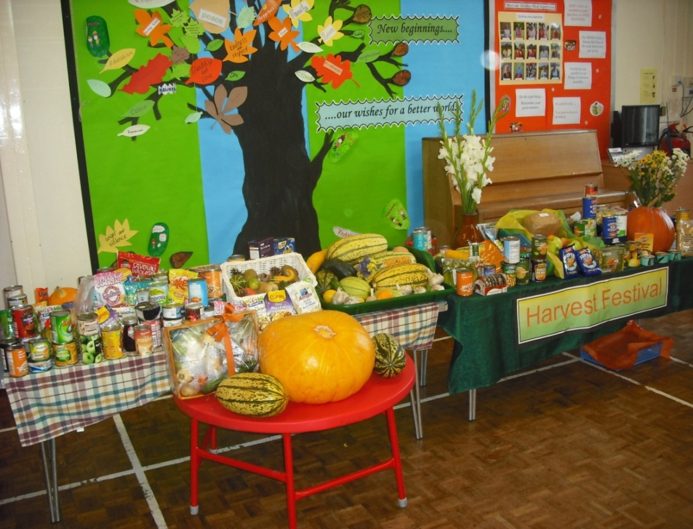


Upton Staffing 2013-2014
Leadership Team  Headteacher - Mrs M Lewis  Deputy Head - Mrs L McGinley  Assistant Head/AEN Manager – Miss D Arthur  Assistant Head (Standards) – Mr D Walker  School Business Manager – Miss E Crine  Year Leaders  Year 3 - Mrs R Lord  Year 4 - Mrs M Papageorghiou  Year 5 - Mrs L Walton  Year 6 - Mrs C Blunden  Teaching Staff  Mrs S Ballen  Mrs C Blunden (YR 6 leader)  Ms A Halliday  Miss F Hare-Winton  Miss C Hayes  Miss N Kemp  Mr P Langridge  Mrs R Lord (YR 3 leader)  Mrs M Papageorghiou (YR 4 leader)  Miss A Povey  Mr S Perkins  Mr G Russell  Miss L Siddall  Miss N Slaney  Miss N Spain  Mrs L Votta  Mr D Walker (Asst. Head)  Mrs L Walton (YR 5 leader)  Miss S Wilson  Mrs T Wilson (AST)  Higher Level Teaching Assistants  Mrs K Cantle  Mrs S Macey  Learning Mentors  Ms Z Danson  Mrs A Turner  Teaching Assistants  Mrs A Baker  Miss L Barratt (Sports Coach)  Ms M Brennan  Mrs R Brown  Mrs L Cobb  Mr J Coot  Mrs N Culver  Mrs J Ellison  Mrs A Frost  Mrs S Harris  Miss L Johnston  Mrs A Laffey  Mrs J Moynan  Mrs K Neal  Miss A Papa-Adams  Mrs J Poole | Teaching Assistants Continued..  Mrs L Regan  Mr B Ricks  Mrs K Shaw  Mr J Slade  Mrs Williams-Verrall  Office Team  Miss L Burke  Mrs D Daley  Ms P Hardisty  Mrs S Plowman  Caretakers  Mr C Goodsell – Senior Caretaker  Mr I Thrumble  Midday Meal Team  Mrs C Tottman – Supervisor  Mrs G Ashbee  Mrs R Brown  Mrs J Byron-Cooper  Mrs H Kasim  Mrs J Moynan  Mrs A Outram  Mrs J O’Donnell  Mrs E Smith  Miss J Wolle  Library  Mrs T Sayer  Swimming Pool  Mrs A Scriven – Pool Manager  Mrs J Baker - Lifesaver  Cleaning Team  Mrs C Beverley  Mrs M Halliday  Miss M Harwood  Mrs J Jackson  Mr C Lacour  Mrs L Shrestha  Mr D Standen  ICT  Mrs J Courtenay  Mr N Wilson  Mr L Hardisty (ICT Apprentice)  After School Club  Mrs A Frost (Supervisor)  Miss A Papa-Adams  Road Crossing Patrol  Mr J Pankhurst
Staff Email Addresses:

Staff Contact | Email Address
Mrs Lewis, Headteacher | headteacher@upton.kent.sch.uk
Mrs McGinley, Deputy Headteacher | lindsey.mcginley@upton.kent.sch.uk
Mr Walker, Assistant Headteacher | dave.walker@upton.kent.sch.uk
Miss Arthur, Assistant Headteacher/SENCO | darci.arthur@upton.kent.sch.uk
Miss Crine, School Business Manager | ellie.crine@upton.kent.sch.uk
Office | office@upton.kent.sch.uk
Mrs Turner and Ms Danson, Learning Mentors | learning.mentors@upton.kent.sch.uk
Mrs Lord, Year 3 Group Leader /  3B Class Teacher | ros.lord@upton.kent.sch.uk
Mrs Wilson, 3G Class Teacher | tessa.wilson@upton.kent.sch.uk
Miss Slaney, 3R Class Teacher | nicole.slaney@upton.kent.sch.uk
Mr Perkins, 3Y Class Teacher | steve.perkins@upton.kent.sch.uk
Mrs Papageorghiou, Year 4 Group Leader / 4Y Class Teacher | michele.papageorghiou@upton.kent.sch.uk
Mrs Ballen, 4B Class Teacher | sharon.ballen@upton.kent.sch.uk
Miss Kemp, 4G Class Teacher | natasha.kemp@upton.kent.sch.uk
Mrs Votta, 4R Class Teacher | lynn.votta@upton.kent.sch.uk
Mrs Walton, Year 5 Group Leader / 5G Class Teacher | lynne.walton@upton.kent.sch.uk
Miss Spain, 5B Class Teacher | nicola.spain@upton.kent.sch.uk
Mr Russell, 5R Class Teacher | george.russell@upton.kent.sch.uk
Miss Hayes, 5Y Class Teacher | corrine.hayes@upton.kent.sch.uk
Mrs Blunden, Year 6 Group Leader / 6R Class Teacher | caroline.blunden@upton.kent.sch.uk
Mr Walker, 6B Class Teacher | email address listed above
Miss Povey, 6G Class Teacher | ashley.povey@upton.kent.sch.uk
Miss Wilson, 6Y Class Teacher | stephanie.wilson@upton.kent.sch.uk
Additional Teachers:
Miss Halliday | anne.halliday@upton.kent.sch.uk
Miss Hare-Winton | fran.harewinton@upton.kent.sch.uk
Mr Langridge | peter.langridge@upton.kent.sch.uk
Miss Siddall | lisa.siddall@upton.kent.sch.uk

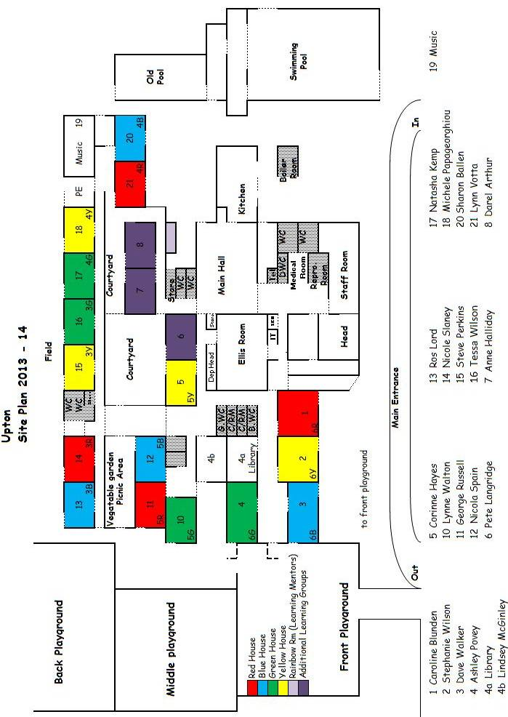

Organisation
Pupils are placed into one of four classes of approximately 32 pupils – blue, green, red or yellow.
All year groups have English and Mathematics lessons daily taught in ability sets
All other lessons are taught in mixed ability classes.
Classes follow a Creative Curriculum. The teacher in charge of each class/set will match the curriculum to the needs of the pupils.

Typical School Day Timetable
8.40 – 8.50 Pupils arrive and lead straight in to their classroom
8.50 School day starts: Register taken
9.10 Assembly SEAL / PHSE theme: Monday
House Teams: Tuesday
Singing: Wednesday
Class Assembly: Thursday
Celebration: Friday
9.30 Assembly ends
10.35 Lower School break – ends 10.50
10.55 Upper School break – ends 11.10
12.15-1.15 Lunch
1.15-3.15 Afternoon lessons
3.15 School ends. Pupils are dismissed onto the front playground to meet their parents/carers

Teaching/Learning
In most classes there is a spread of ability ranging from those pupils who find few problems with learning to those who have some specific difficulties and who find learning problematic. For these latter cases there is a specialist teacher to advise and support the learning.

Parental Input
Parents are most welcome to assist the teaching staff on a voluntary basis. The most valuable assistance is listening to children read and providing opportunities to develop oral skills in a small group situation. Parents also help with practical tasks and experience days. As part of the Homework Policy parents are encouraged to be directly involved in helping their children with set tasks. All volunteers need a current CRB check which is quick and simple to complete through the school office.

Use of premises
Children should use the footpath entrance gate leading to the playground. The morning drop off zone is very useful for safely delivering the children to school if they come by car. The children should not arrive at school before 8.30am, (an especially important point during bad weather), nor after the 8.50 am whistle. Supervision is only provided from 8.40, ten minutes before the beginning and until 3.30, fifteen minutes at the end of each day.

Parking
Car drivers are asked to respect the road markings at the school entrance, park on Broadstairs Road, avoiding residents' driveways. The school is then a short walk around the corner. This will help keep congestion to a minimum. Parking on the zig-zag lines in Edge End Road could result in an instant fine. The school drive and car park should not be used by parents at any time of the school day.

Lost Property
While we do our best to return lost property to its rightful owner, the school does not accept responsibility for loss or damage to the personal property of children. The marking of clothes and other property with the owner's name is, therefore, of the greatest importance. Lost property is located in the year group areas. You are advised that there is no insurance for items lost or stolen, but cover can normally be arranged through your own home insurance policies.

Jewellery, Valuables, Money
Jewellery should not be worn to school and valuables such as watches are best left at home as we cannot accept responsibility for them. Money such as bus fares should be kept to a minimum and may be left with the class teacher at her/his discretion, for safe keeping. Valuables and money should never be left in lockers. All money brought to school is the responsibility of the pupil unless it is handed to an adult for safe keeping. Mobiles phones should not be brought into school, but if they are they should be switched off, kept in the locker all day (they are not allowed to be taken out at breaktimes) and school takes no responsibility for them.

School Meals
Pupils may buy a healthy school meal at lunch time, cooked by Caterlink. A cooked meal plus sweet is provided. A vegetarian meal can be supplied if requested. For those children taking a school meal, payment should be made in advance on the first day of the school week. The charge at present is £10.50 per week, payable in advance. Pupils can choose daily to have a school meal. Free meals are available to those children whose parents are in receipt of Income Support. More information is available from the school office. We urge all eligible parents to apply please.

Alternatively, pupils may bring a packed lunch. In this case we ask you to ensure that food is brought in a securely-packed manner (e.g. a rigid plastic box) labelled with name and class. Drinks in secure plastic containers may be brought in. No cans or glass bottles, please. We operate a fruit shop for the pupils at morning break time. Sweets and chewing gum are not permitted at school.

Charging Policy
In accordance with the Education Reform Act 1988, the Governors of Upton Junior School give notice that charges may be made for the following:-
- Individual or small group tuition in playing any musical instrument.
- For board, lodging and travel on a residential trip.
- Recovery cost of breakages or damage caused as a result of a pupil's behaviour.
- For optional extras, e.g. cost of materials for craft, where parents have indicated a wish to own the finished article.

NB It is recognised that parental agreement must be obtained in advance of any pupil's participation in any activity involving a charge.

Voluntary contributions will be invited from parents towards the cost of a school activity, e.g. a school trip during school hours, Design & Technology days, theme days and swimming costs.
No child shall be barred from an activity because contributions have not been made. However, it should be noted that a lack of contributions may result in the cancellation of an activity.

School Voluntary Fund
We ask parents to contribute £5 per child at the beginning of every school year to our School Voluntary Fund. This fund pays for many ‘extras’ during the school year.

Accidents and Emergencies
Parents are informed as soon as possible when a serious accident occurs. Minor injuries are attended to by the supervisory staff at lunch time and office staff, who hold first aid qualifications. Please note that while every effort is made to act as a reasonable parent might do, individual parents should be prepared, when asked, to respond to an accident themselves. Parents/guardians should ensure that at least two emergency contact names and telephone numbers are given to the school and that these details are updated regularly.

First Aid Procedures
Health and Safety regulations require a wound to be washed with clean water or sterile wipe and then apply a sterile dressing. We cannot apply creams or lotions. We cannot give aspirin or similar analgesics without parental consent. First-aiders normally wear protective gloves while administering first aid. An accident book is kept and parents are notified immediately if a child needs to be taken to hospital. An ambulance is called when a child is unconscious or has become incapacitated, e.g. a broken leg.

Procedure for Administering Medicine in School
We are advised that most medicines need not be administered at school. However, there are some circumstances when it cannot be avoided. On these occasions a medicine form must be completed by the parent before it can be administered in school.

Pupil Absence
The Education Act 1996 Section 444 (1) clearly states that...
‘if any child of compulsory school age, who is a registered pupil at a school, fails to attend regulalry, the parents of the child shall be guilty of an offence’
Parents are also required to explain all absences which, in the case of illness, may have to be supported by medical evidence.
Pupil absence may only be authorised by the Headteacher and only in certain circumstances, such as
- Illness reported to the school either by phone or letter from the parent.
- Emergency hospital or dental appointments.
- Exclusion of pupil for medical and/or behaviour problems.

Any requests for holiday absence during term time will not be authorised.

Homework
School-related work undertaken at home is encouraged as part of the home-school partnership. The extent of work is dependent on the age and ability of the child and is designed to support the school’s curriculum. It will usually require a daily time commitment of about 15 minutes for year 3 pupils to around 30 minutes for year 6 pupils. A copy of our homework policy is given to new parents as a matter of course and Year Group Leaders will send home information regarding Homework at the start of the school year.

Pupil Voice
We want all children attending Upton to have an opportunity to be involved in their school and value the opinions they hold. We have a ‘Pupil Council’, where pupils meet to discuss various issues of importance to them and the school. Children are given the opportunity to discuss the issues raised through Pupil Council in assembly and can vote for issues they feel important.

School Travel Plan
This consists of an action plan to improve traffic problems in the local area and encourages parents to look at alternative ways to improve the daily journey to and from school.
Uniform
We expect all pupils to wear full school uniform. It can be purchased from the National Schoolwear Centre, Margate or online at www.yourschooluniform.com

Details of the Upton uniform are as follows:-
Coat or jacket for school - navy blue, grey or black preferred
School fleeces - available from National Schoolwear Centre
School sweatshirts - available as above
Pullovers or cardigans - navy blue
Girls' skirts/tunics/trousers/shorts - navy blue or grey
Girls' blouses/polo shirts - white or light blue
Girls' summer dresses - any suitable material in blue and white, in a design appropriate to school wear.
Boys' trousers/shorts - grey
Boys' shirts/polo shirts - white or light blue
Shoes - black, flat heels
Trainers are not acceptable
Socks or tights - navy, black, grey or white only
PE/Games kit - black or white plimsolls (lace less type
preferred)
- trainers for outside PE/Games
- a plain white T shirt or school t-shirts in class colours are available from National Schoolwear Centre
- black shorts. (Skirts may be worn for games)
Outdoor - track suits are recommended for outdoor lessons in winter

It is essential that all children are properly kitted out for all PE lessons.
Children should have appropriate tops, shorts, socks and footwear for play on the field in all types of weather.
Kit should be kept in a suitable named bag which can be kept in their locker.
Please note, girls as well as boys should wear shorts for gymnastics lessons.
Pupils should not wear articles of jewellery such as rings and earrings or watches at any time because they may cause injury to themselves or to their fellow pupils. Temporary “keepers” in newly pierced ears must be covered by tape.
Rules regarding swimming are different – see below.
Long hair (shoulder +) must be tied back off the face with a simple blue or black band for boys and girls. We ask that you respect our uniform policy and consider your children’s hair style, in that it is appropriate for school and in line with school policy.

Swimming
Girls should wear a one-piece bathing costume (and preferably), a bathing hat.
Boys should wear swimming trunks or tight fitting shorts (not knee length type beachwear, baggy shorts).
Earrings must be removed. Please note – taping of ear studs is not acceptable as they could damage the pool liner.
Long hair must be tied back and covered by the bathing hat.
Children will need a waterproof bag to hold their towel and costume.
Parents should please keep the school informed by letter of any foot condition such as verrucae and children should be equipped with verrucae socks.

Protective Clothing
This should be provided for "messy" activities. A large old shirt or apron, which covers arms and body is ideal.
PLEASE LABEL ALL UNIFORM CLEARLY WITH YOUR CHILD’S NAME
Assessment and reporting to parents
Our present reporting and feed-back system consists of the following arrangements:
- A meeting early in the academic term (usually end of term 1) for an open discussion where you as parents can discuss the coming year and share any information about your child with the class teacher
- A mid-year meeting, usually at the end of term 4 between parent and teacher when work can be seen and discussed and an opportunity is available to raise matters of concern.
- Progress reports can be arranged by mutual agreement with the teacher. These meetings may be requested by either parent or teacher.
- A written report, which is the teacher's assessment of pupil progress for that year is sent out in the summer term.
- An opportunity for an end of year meeting between parents and teacher for discussion on progress when the report and work may be discussed.
- Targets in Reading, Writing and Maths are sent home three times a year as part of every child’s ‘Individual Education Plan’
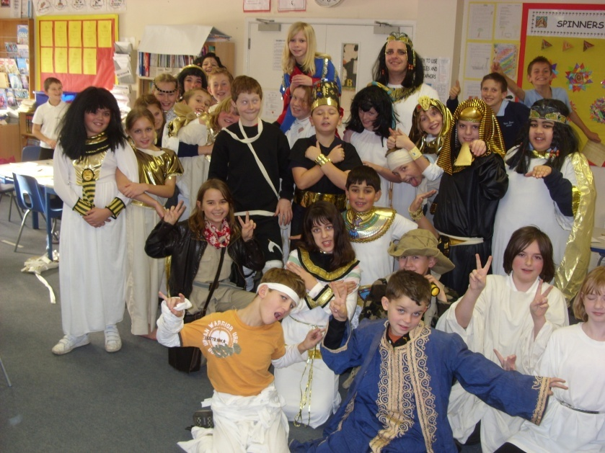

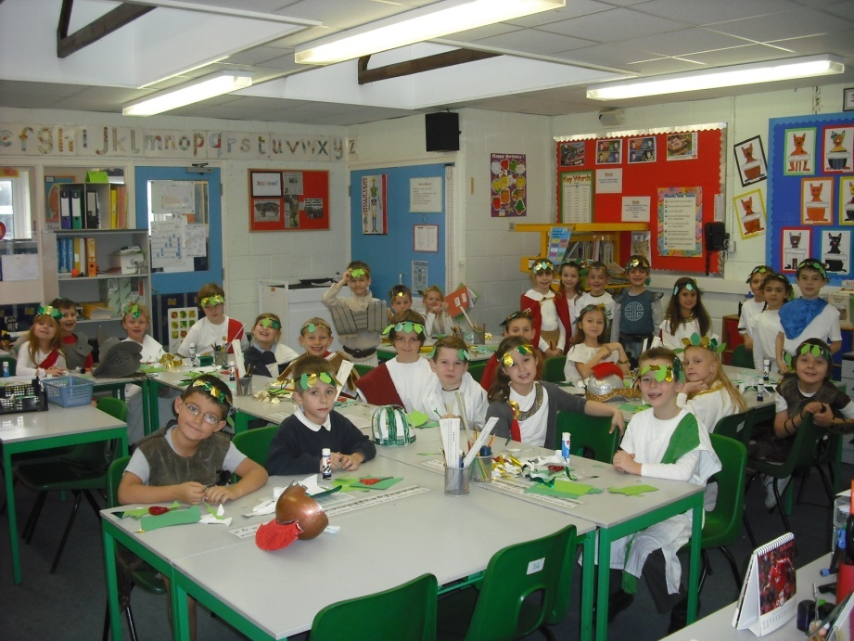
Section 2
Curriculum
Page
- Curriculum Statement 19
- Creative Curriculum topics 19
Core Subjects
- English 19
- Mathematics 19
- Science 19
Foundation subjects
- ICT 20
- Design & Technology 20
- History 20
- Geography 20
- Music 20
- Art 21
- PE & Sport 21
- Modern foreign language 21
Other subjects
- PSHE (personal, social & health education) 21
- Cultural awareness 21
- Environment & outdoor education 21
- Religious Education 21
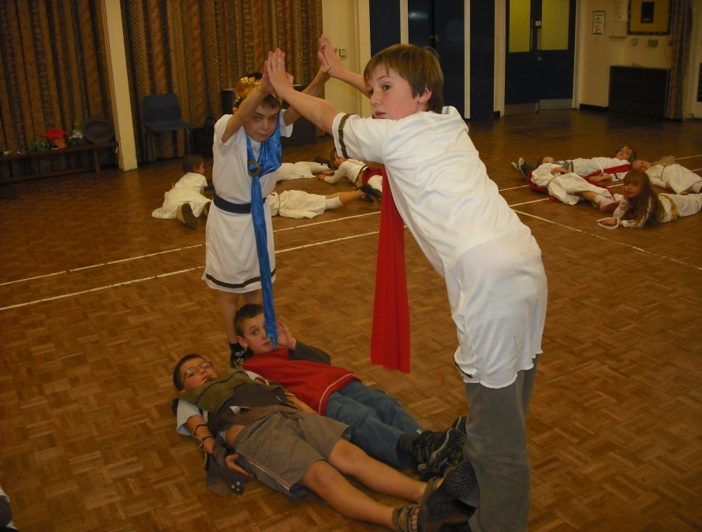

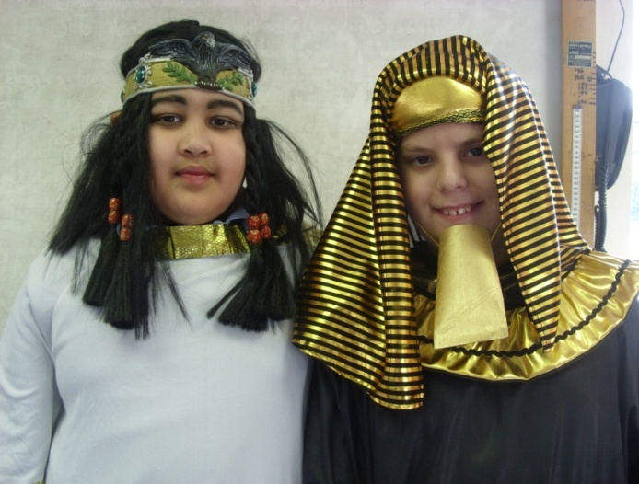

Our Curriculum Statement
The ten subjects making up the primary curriculum are either taught separately or are integrated into the Creative Curricular themes. Work is planned termly giving each year group a broad basis for incorporating national requirements and allowing appropriate topic work to develop in individual classes. A table of the broad Creative Topics covered by each year group is listed below. Programmes of study for pupils are drawn from this overall provision. There are excellent library and ICT facilities to support the curriculum; children are able to borrow fiction & non-fiction books, as well as making use of the reference sections of the library. All pupils have Internet,laptop and I-Pad access to enhance their learning.

Creative Curricular Topics

Year group | Term 1 | Term 2 | Term 3 | Term 4 | Term 5 | Term 6
3 | Getting to know you | The past | What a Wonderful World | What a Wonderful World | Treasure! | Minibeasts
4 | Groovy Greeks | Christmas all over the World | Habitats and Homes | Henry 8 | Broadstairs – a place by the sea | Broadstairs – a place by the sea
5 | All change | All change | Water water everywhere | Round we go | Moving & grooving | Animals around the World
6 | Sustainability | A Place in the Sun | A Place in the Sun | A Place in the Sun | Children in World War 2 | Children in World War 2

Core Subjects

English
We promote a positive and confident attitude towards English and help pupils to develop the skills they need to express themselves clearly across the whole curriculum. Daily English lessons are planned using the new National Curriculum.
English is presented as an exciting and challenging subject. We promote an appreciation of the creative use of language through listening, reading, writing and performance and encourage pupils to express their opinions and to develop their ability to explain their reasoning.

Mathematics
Our aim in mathematics is to ensure that each child acquires and becomes competent in the use of basic computational, investigational and practical mathematical skills. The daily Maths lesson follows the ‘new’ National Curriculum and emphasises the ability to use mental calculation strategies. Children are encouraged to learn number facts and tables and to use informal jottings to help them with their work. Areas of work include number, algebra measures, shape and space and data handling.

Science
Our aims in Science are as follows:
- To develop pupils’ enjoyment and interest in Science and an appreciation of its contribution to all aspects of everyday life.
- To build upon pupils’ curiosity and sense of awe of the natural world
- To use a planned range of investigations and practical activities to give pupils a greater understanding of the concepts and knowledge in Science
- To develop pupils’ practical skills and their ability to make accurate and appropriate measurements
- To develop pupils’ use of ICT in their science studies

Foundation subjects – often taught as part of a Cross Curricular topic

Information & Communication Technology
At Upton, we believe that ICT is vital in preparing our children for their future! ICT is taught as a discreet subject as well as developing pupil skills and knowledge in the use of ICT through all appropriate curriculum areas

Design and Technology
The aim of activities under this heading is to help pupils operate effectively and creatively in the modern world. The activities support and link other subjects in the curriculum. The emphasis is on developing valuable personal qualities such as imagination, persistence and disposition to see a job through to the end and the ability to make judgements of many kinds - technical, economic, social, aesthetic and others. For junior pupils the activities will largely involve finding solutions to problems, e.g. "How strong is a wall?" or "What is the best shape for a bridge?"
The subject will be taught, in the main, through Design & Technology days. Pupils will spend 1 day each term working together to produce a finished product. On each day they will have the opportunity to; evaluate similar products; develop relevant skills; design & make a product; and finally to evaluate their finished models in the light of what was intended. Currently the D&T days in each year group are as below

Year group | Autumn | Spring | Summer
3 | Sandwich making | Moving Toys | Celtic shelters
4 | Moving books | Lighting a lamp | Beach bag
5 | Bread making | Umbrellas | Pyjama case
6 | Cams | Cases | Shelters

History
History units are planned to be fun and interesting for the children. Empathy for the eras is developed through theme days. Year 3 has a Roman Day, Year 4 a Greek day, Year 5 a Victorian day and Year 6 an Egyptian day. Visiting speakers are organised and, where possible, visits are arranged to relevant historical sites.
Knowledge and Understanding is nurtured through using evidence from artefacts and pictures, etc. to answer questions.
A gradual grasp of time and chronology is built on by using timelines.

Geography
Geographical skills are incorporated into the units through fieldwork and the use of maps and atlases. Secondary sources of films, ICT and TV programmes are used to inspire and enthuse the children into a love and curiosity of other places, cultures and people.

Music
Music is a performing art and the aims of all activities associated with it are to promote understanding and appreciation of its various forms and elements, including World Music, through participation in listening, performing and composing. Music is recognised throughout the school as being an essential part of a child’s education, promoting self-discipline, independent reasoning skills, team work and fun. Many opportunities exist for all children to take part in extra-curricular musical activities. Every child in the school can learn the recorder and opportunities exist for group tuition on school string and brass instruments.
Facilities for instrumental tuition are available from both Kent Music School and private, licensed teachers.

Art
In Art our aim is to introduce the children to a wide variety of techniques and provide practice in the use of tools and media to develop both their skills and visual awareness. Pupils will be given the opportunity to develop both their skills and visual awareness in drawing, printing, painting, 3D, design, textile, collage and ICT. They will also be encouraged to develop their knowledge and understanding of other artists from different periods, styles and cultures.

PE and Sport
The aim of physical education is to help pupils to develop a range of creative and skilful movement together with an awareness of physical growth and good health. The qualities of good sportsmanship are strongly encouraged. Activities include gymnastics, swimming, dance, dance-drama, athletics, development of ball and apparatus skills and formal team games. The school benefits from an excellent swimming pool, playing fields and from staff and parent helpers who further the school’s curriculum with several extra-curricula activities and events. Pupils are able to participate in athletics, cricket, hockey, netball, rounders, rugby, soccer, gymnastics, dance, swimming and tennis.

PSHE
This subject is not dealt with in isolation but forms an integrated part of the whole school curriculum. Guide-lines encourage the management of relationships in a responsible and healthy manner. The programmes will form part of an overall policy on personal and social education involving matters, such as sex education, health, hygiene and citizenship.

Cultural Awareness
Pupils are encouraged to be aware of and receptive to other cultures.
Basic French conversation is taught throughout the school as a curricular subject. Broadstairs town is twinned with Wattignies near Calais and our annual year 6 pupil exchanges with the local school have proved very successful.

Outdoor Education
There is an Environmental area in the school grounds, which has a pond, numerous species of trees and flowers, as well as a wild-life area. The area gives the opportunity for nature study and appreciation of the environment.
Money raised contributes to various environmental initiatives such as growing seeds, and buying plants and trees for the various areas around the school. The school has its own vegetable garden and an Environment Club that meets weekly.

Religious Education
As a County Primary School, Upton is not affiliated to any particular religious denomination. However, our teaching and the daily Act of Worship are broadly Christian in nature.
Through a variety of approaches we try to make the children sensitive and considerate towards the needs of others and help them form attitudes and patterns of behaviour which derive from a reasonable moral and religious code.

Section 3
Special & Additional Needs

Page
- Additional Education Needs 23
- Special Educational Needs (SEN) 23
- School Action 23
- School Action Plus 23
- Statutory Action 23

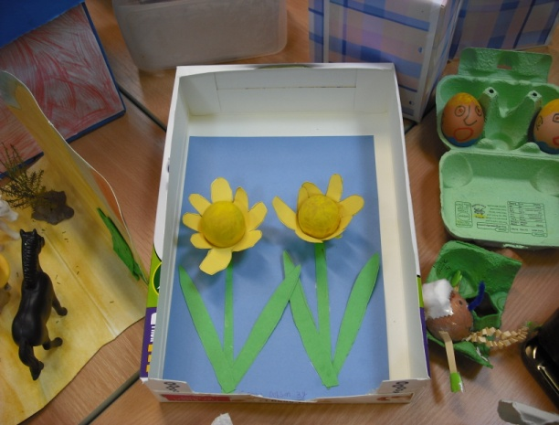

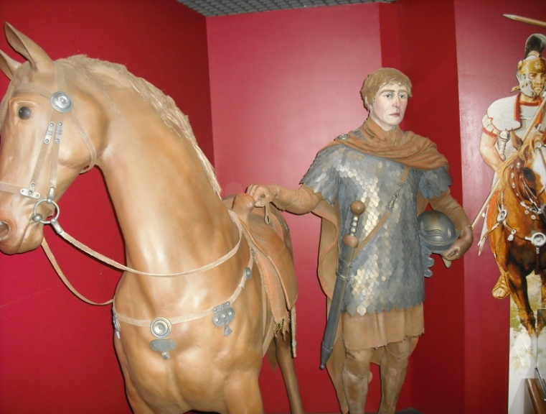

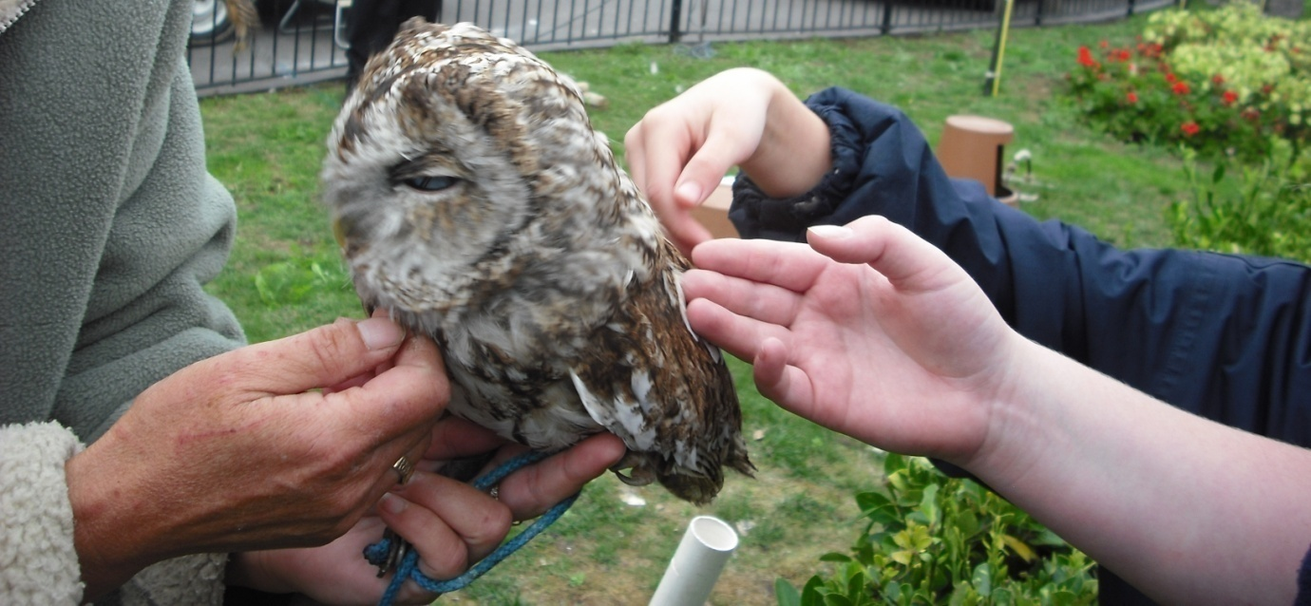
Additional Educational Needs

Admissions for all pupils including children with special educational needs are fully inclusive. In accordance with the Disability and Discrimination Act 2006 we will undertake to promote equality of opportunity and promote positive attitudes within our community. We pride ourselves on being an inclusive school and in accordance with the Every Child Matters Bill 2005 promote being healthy, staying safe, enjoying school and achieving, plus making a positive contribution within the community. Upton is good at implementing safeguarding procedures to enable all pupils to develop within the school community. We also support Looked After Children, Children with English as an Additional Language and other vulnerable children as required.

Special Educational Needs (SEN)

Upton aims to enable pupils with SEN to reach their full potential, and develop as full rounded individuals.

Children have special educational needs if they have a learning difficulty which calls additional educational provision to be made for them.
Children have a learning difficulty if they:
● have a significantly greater difficulty in learning than the majority of children
the same age; or
● have a disability which prevents or hinders them from making use of
educational facilities of a kind generally provided for children of the same age in schools within the area of local education authority.

Special educational provision means:
● educational provision which is additional to, or otherwise different from, the
educational provision made generally for children of their age in schools maintained by the LEA, other than special schools, in the area.

Many pupils receive some additional support from time to time in school; this in itself does not necessarily constitute a special need. For children identified as having special needs by the school, the action taken will be described as school action, school action plus or statutory action. Most pupils will not need an Individual Education Plan (IEP).

School Action
If a pupil has made little or no progress, the school will decide on the action to be taken. This could include group help, different learning materials, equipment or additional adult time.

School Action Plus
Sometimes when a pupil makes little or no progress, despite school action, advice from external agencies will be sought. In consultation with parents and pupils, an IEP or Provision Map will be written and reviewed at least twice yearly.

Statutory Action
Is taken when a pupil makes very little progress, no progress or has a major disability. An assessment is then undertaken by the LEA, that sometimes results in a STATEMENT of special educational needs being issued.

Parents and carers are invited to participate in discussions and become actively involved in supporting and helping children with SEN at all stages. Indeed, this partnership between Upton and parents is highly welcomed.

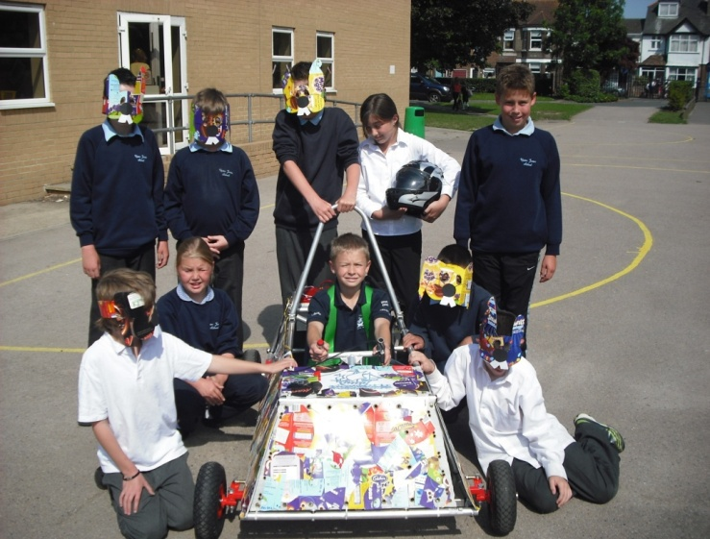
Section 4
Pupil Safeguarding

Page
- Behaviour/discipline policy 25
- Anti bullying policy 25
- Child Protection Policy – parents information 26
- Child Protection Procedures 26
- Safeguarding Procedures 26


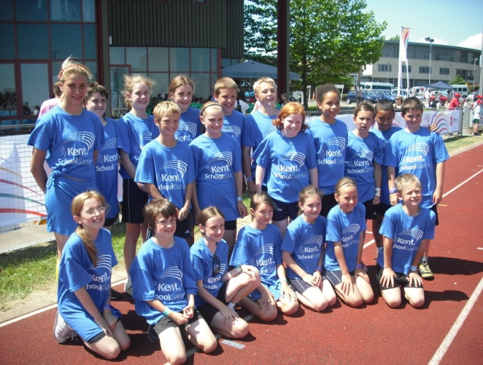
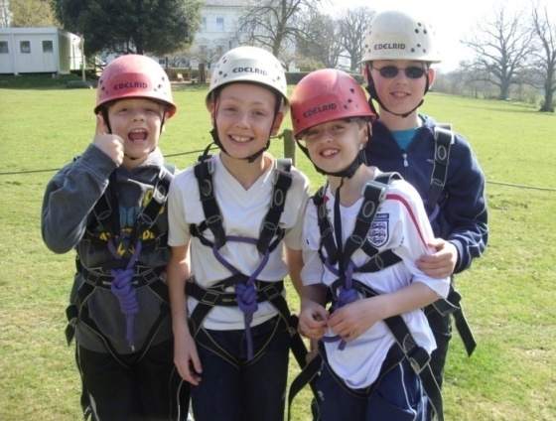

Behaviour/Discipline Policy

In order to continue to provide the ethos we have created in our school and the sense of pride in belonging to our community we expect all our children to adhere to a set of simple rules.
We are justly proud of our children and their behaviour is very good. We value all our children equally and adopt a family approach to life at Upton. ‘Care for self and others’.
Our success is based upon the strong partnership we have with parents/carers. Your support in this partnership is vitally important.
Our simple set of rules are adopted for the health, safety and well being of everyone in school and these are explained to all children on entry.
These are called our Golden Rules and are as follows
- Remember everyone is special and important
- Treat everyone as you would like to be treated
- Listen when others are talking
- Try your best always
- Take care of people and property
- Use the school responsibly

The schools Behaviour/Discipline Policy is available on our website www.upton.kent.sch.uk. If you require a paper copy please ask at the school office.
We reward good behaviour and challenge unacceptable behaviour firmly.

Anti Bullying Policy
The schools Anti Bullying Policy is available on our website or from the school office.

“Bullying may be distinguished from other unacceptable forms of aggression in that it involves dominance of one pupil by another, or a group of others, is pre-meditated and usually forms a pattern of behaviour rather than an isolated incident. Many pupils experience bullying at some point. The fact that incidents have not been reported to staff does not mean they are not happening. Bullying or other forms of harassment can make pupils’ lives unhappy, can hinder their academic progress, and can sometimes push otherwise studious children into truancy. In extreme cases it can lead to pupils taking their own lives.”
(DFE Circular 8/94 Pupil Behaviour and Discipline).

Every child in school should feel equally valued, safe and secure.
Bullying in any form, be it verbal, physical or indirect will not be tolerated. We try to operate a policy of speaking out and encouraging pupils to tell an adult if they are being bullied.
At every stage we need to know who is bullying when, where, who and why. We need to be aware of areas in the school where it might occur and keep them covered.

Child Protection Policy - Parents' Information

It is the policy of the school to report to the authorities all incidents of child abuse brought to the attention of the Child Protection Officer and/or Headteacher. The authorities designated by law to receive such reports are - Police, Social Services or NSPCC.

Parents should be aware that the above duty of care is placed on the school as a result of the government’s Children’s Act and subsequent legislation. There may be occasions when reports are given to the relevant authority without reference to parents. It would then be the decision of that authority when and where to inform those with parental responsibility.
(See note 2 below)

Child Protection Procedures
In the event of a child reporting abuse of himself/herself or the abuse of another child to a responsible adult, that adult will take the following action:-

- Reassure the child that they are doing the right thing in telling.
- Follow the Guidelines for Educational Staff provided by the LEA.
- Inform the Child Protection Officer (Mrs D Arthur & Mrs L McGinley) in the school and/or the Headteacher.

The adult will accept what the child says at face value and not express an opinion about the validity of the disclosure. The adult will not interrogate the child, or comment on the disclosure or express an opinion. Once the information has been passed to the Child Protection Officer the adult will maintain confidentiality and take no further action.

The Child Protection Officer will consider the information and will pass the information to the relevant authority, record the details and then take no further action unless instructed by the relevant authority. If the information concerns an employee at the school then the Customer Services Manager of the LEA will be informed and advice sought.

Please note that although it is the role of the school to be alert to the possible signs of abuse and to report concerns, it is not the responsibility of school staff to make enquiries of parents or others involved. In some cases it might actually be counter-productive to do this. Investigation is the statutory responsibility of Social Services, the NSPCC and the Police and should be left to them.

Safeguarding procedures
In these days of ever changing technologies safeguarding pupils at Upton School is very important.
The Governing body and staff of Upton Junior School take seriously our responsibility under section 175 of the Education Act 2002 to safeguard and promote the welfare of all children; and to work together with other agencies to ensure adequate arrangements are in place within our school to identify, assess, and support those children who are suffering harm…

As part of the ethos of the school we are committed to:
- Maintaining children’s welfare as our paramount concern
- Providing an environment in which children and young people feel safe, secure, valued and respected; confident to talk openly and sure of being listened to
- Providing suitable support and guidance so that students have a range of appropriate adults who they feel confident to approach if they are in difficulties
- Using the curriculum to provide opportunities for increasing self awareness, self esteem, assertiveness and decision making so that students have a range of contacts and strategies to ensure their own protection and understand the importance of protecting others
- Working with parents to build an understanding of the school’s responsibility to ensure the welfare of all children including the need for referral to other agencies in some situations
- Ensuring all staff are able to recognise the signs and symptoms of abuse and are aware of the school’s procedures and lines of communication
- Monitoring children and young people who have been identified as “in need” including the need for protection; keeping confidential records which are stored securely and shared appropriately with other professionals
- Developing effective and supportive liaison with other agencies

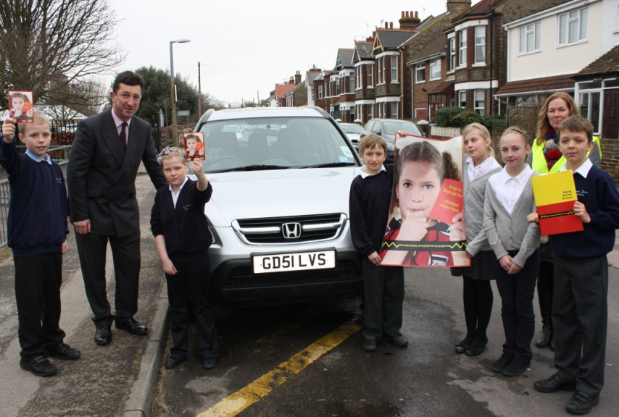
Section 5
General Information
Page
- Complaints procedure 29
- Health & safety Issues 29
- Health & Safety Procedures 29
- Visitors/Security 29
- Other Information 30
- Access to documents 30
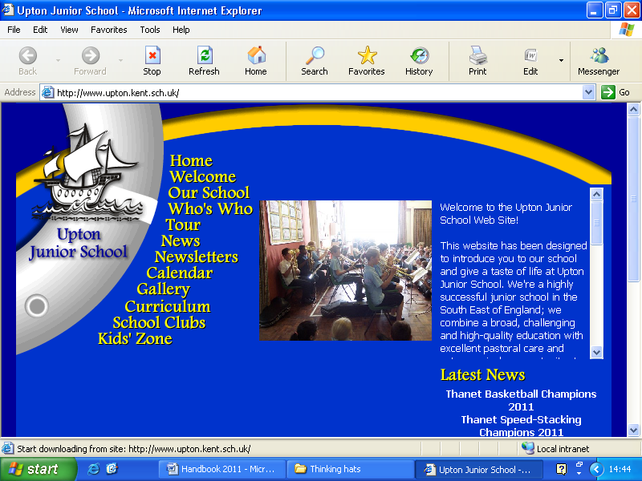
- Thank You 30

- Our website gives you information too. Check it out at

www.upton.kent.sch.uk

Other helpful websites include:-

www.kent.gov.uk

www.kenttrustweb.org.uk

www.ofsted.gov.uk

Complaint and Compliments Procedure
In the ideal world complaints would not exist. We do not however, live in an ideal world and complaints can arise from time to time, despite our best efforts.

Most queries/complaints can be routinely dealt with by contacting the relevant person.

There may be occasions when you need to take your concerns further, then the regulations provide for four compulsory stages and an optional fifth. Please ask at the Office for information on the correct procedure.

Within 10 school days the complaints officer must either inform the complainant of a decision (in writing, giving the reasons for the decision, advising of a further right of appeal, and if appropriate, the timetable for any action), or tell the complainant when a decision will be made.

A complainant will be able to withdraw his or her complaint at any stage. There is an accelerated procedure for urgent or serious complaints.

Some complaints have to follow a statutory process if they are unable to be resolved in school. Complaints procedures already exist for:-
Curriculum and religious education
Admissions and exclusions
KCC financial regulations
Legal matters
Personnel matters, including grievances
Health and safety
Home to school transport
Special Education Needs
If a complaint is about any of these areas then contact the Headteacher for initial details of the procedures involved. As a school we adopt a positive attitude about complaints and feel that with early involvement we can prevent a later crisis.

Conversely, the actions of a person or a particular event may have surpassed your expectations and in recognition of this, you may wish to complete a ‘Compliment Form’. These are shared with staff and are genuinely appreciated.

Health and Safety Issues

Health & Safety Procedures
The Governors make every effort to ensure that Upton provides a safe and secure environment for all its users, especially its children.
We have strict guidelines and expect all to follow them to avoid harm to themselves and others.

Visitors/Security
All parents/carers and other visitors are welcome but must report to reception before proceeding to other areas of the building or grounds. Our visitor’s book must be signed and an identity badge worn. Our concern is for the safety and welfare of our pupils and all users of the school. I hope you support and maintain this policy.

Other Information
If you require any information please, in the first instance, contact the school office where they will be able to help and if necessary to refer you onto another member of staff. Alternatively you can email the headteacher or appropriate member of staff. (Staff emails were listed at the beginning of this document)

Access to Documents
All documents pertaining to the organisation, requirements, advice and reports of the Department for Education and Employment, the LA, the School Governors, and the curriculum undertaken, together with school policies, are available at the school for inspection. 48 hours advanced notice is usually requested.

Thank you for taking the time to find out a little more about Upton Junior School. If you would like to arrange a visit to come and see us at work please ring the school office or email the headteacher to make an appointment.

We see the education of your child as a partnership between parents, families and school and are confident that your child will thrive during their time with us at Upton!

